Experiment: Implementation of Linear Regression (LR) Algorithm in Python
Aim
To implement the Linear Regression (LR) algorithm in Python and predict the output using a suitable dataset.
Theory
Linear Regression is a supervised machine learning algorithm used to predict a continuous value by establishing a linear relationship between the input (independent variable) and the output (dependent variable).
It finds the best-fit line that minimizes the prediction error.
Procedure
- Import the required Python libraries.
- Load the Diabetes dataset.
- Split the dataset into training and testing sets.
- Create the Linear Regression model.
- Train the model using the training dataset.
- Predict the output for the test dataset.
- Display the model coefficients, intercept, and predicted values.
- Evaluate the model using the Mean Squared Error (MSE) and R² Score.
Python Program
from sklearn.datasets import load_diabetes
from sklearn.model_selection import train_test_split
from sklearn.linear_model import LinearRegression
from sklearn.metrics import mean_squared_error, r2_score
# Load Diabetes dataset
data = load_diabetes()
X = data.data
y = data.target
# Split dataset into training and testing
X_train, X_test, y_train, y_test = train_test_split(
X, y, test_size=0.3, random_state=1
)
# Create Linear Regression model
model = LinearRegression()
# Train the model
model.fit(X_train, y_train)
# Predict
y_pred = model.predict(X_test
# Display Results
print("Model Coefficients:")
print(model.coef_)
print("\nIntercept:")
print(model.intercept_)
print("\nActual Values:")
print(y_test[:10])
print("\nPredicted Values:")
print(y_pred[:10])
# Evaluation
print("\nMean Squared Error:", mean_squared_error(y_test, y_pred))
print("R2 Score:", r2_score(y_test, y_pred))

Output
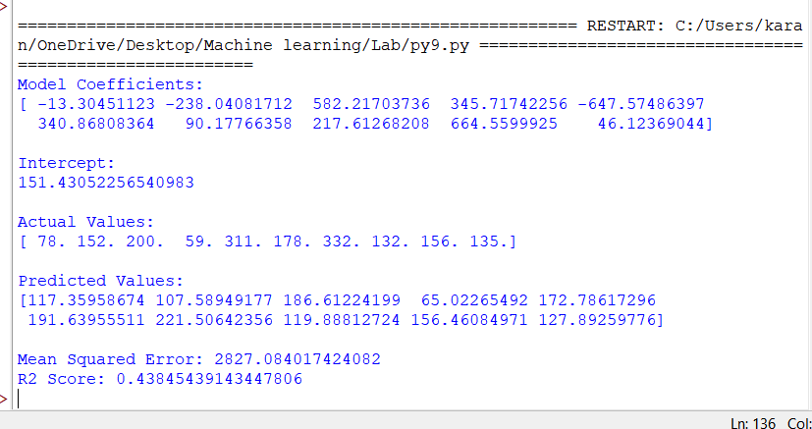
Result
The Linear Regression algorithm was successfully implemented in Python. The model was trained and tested using the Diabetes dataset, and the predicted values were evaluated using Mean Squared Error (MSE) and R² Score.

